

Aberdeen City Integration Joint Board

Combined Terms of Reference

Date Created: | November 2022
Version: | V 3.0
Location: | Governance
Author (s) of Document: | Jess Anderson, ACC Legal Services
Approval Authority | IJB
Scheduled Review: | July 2027
Effective Date: | 30 June 2026
Changes: | March 2023  June 2024  June 2026

IJB Structure Chart

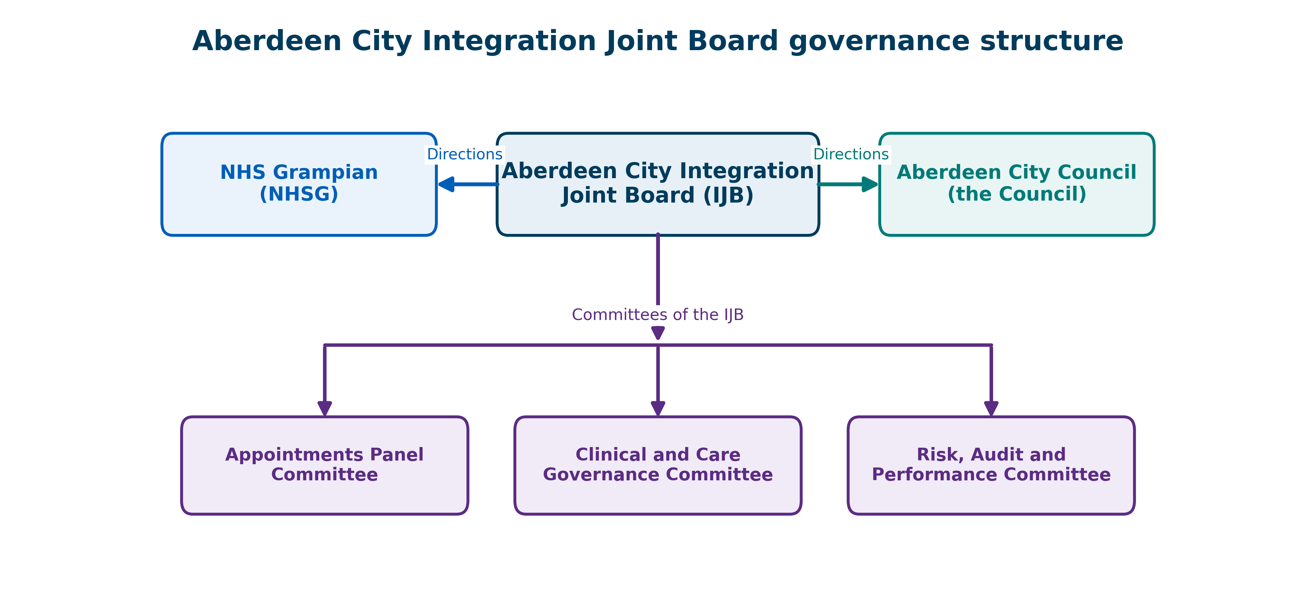

Introduction

- The Aberdeen City Integration Joint Board (IJB) ultimately derives its authority from the Public Bodies (Joint Working) (Scotland) Act 2014. It was created by Aberdeen City Council (the Council) and NHS Grampian (NHSG), the “Partners”. These partner organisations delegated functions to the IJB, which are detailed in the Aberdeen City Integration Scheme.

- The IJB is permitted by article 17 of the Public Bodies (Joint Working) (Integration Joint Boards) (Scotland) Order 2014 to form committees for the purpose of carrying out such of its functions as it determines.

- The IJB has formed three committees: the Risk, Audit and Performance Committee, the Clinical Care and Governance Committee and the Appointments Panel Committee.

- Any decision taken by a committee is deemed to be a decision of the IJB as a whole.

- The IJB may determine a matter which would ordinarily fall within the remit of a committee.

- The IJB sets the Terms of Reference for its committees annually when reviewing the Scheme of Governance. As part of this process, the Chief Officer will ensure that officers will review the Terms of Reference.

- Non-material amendments to the Terms of Reference may be made by the Chief Officer, following consultation with the Chair and Vice-Chair of the IJB and the Chairs of the Committees. Any such amendments do not need to be approved otherwise by the IJB.

- Any non-material amendments will be notified to the members of the IJB when completed.

Title | Aberdeen City Integration Joint Board (IJB)
Lead | Chief Officer
Date | June 2026 | Version | 4.0

Quorum
Six voting Members, with at least three Members from each constituent authority

Matters Reserved to the IJB
1).The IJB shall consider the following;

a) Matters which are reserved by law;
b) Matters which the IJB has chosen to reserve under paragraphs 2 to 10 below, and;
c) Any other matter that the Chief Officer determines appropriate to report to the IJB.

2). Any function or remit delegated under the Aberdeen City Integration Scheme, which is bound to be undertaken by the IJB itself;

3) Establish such committees as may be considered appropriate to conduct business and to appoint and remove Chairs, Vice Chairs, members of the IJB, its committees in accordance with the IJB’s Standing Orders;

4) Approval of the Medium-Term Financial Framework, Financial Regulations, Reserves Policy and Budget Protocol.

5) Approval or amendment of the Scheme of Governance, or any part thereof;

6) Commission, in so far as it relates to business services, the engagement of consultants, or external advisors for specialist advice, such as; administrative, accounting or legal support, where this requires authority from the IJB in respect of the Partners’ own procurement rules and Schemes of Delegation;

7) Co-operate, or combine with other Integration Joint Boards in the provision of services other than by way of collaborative agreement;

8) Approve or amend the Strategic Plan and Annual Performance Report;

9) Make, and thereafter issue, Directions to the Partners under sections 26 and 27 of the Public Bodies (Joint Working) (Scotland) Act 2014, in line with the Aberdeen City Integration Scheme and legislative framework;

10) Approval of the Clinical Care Governance Framework.

2. Risk, Audit and Performance Committee
Title | Risk, Audit and Performance Committee
Executive Lead | Depute Chief Finance Officer
Date | June 2026 | Version | 3.0

Purpose
To give assurance to the IJB that there are robust arrangements for:
- risk management;
- financial management;
- service performance; and
- governance.

This includes services hosted by Aberdeen City’s IJB on behalf of other Integration Authorities.

Quorum
Two voting Members, one representative each from the Council and NHSG.

Remit and Responsibilities
Investigation

- Instruct further investigation on any matters which fall within its remit, reporting the findings of such an investigation to the IJB.

Audit

- Ensure there is an effective Internal Audit Function that meets the Public Sector Internal Audit Standards and that it provides appropriate independent assurance to the Committee, Chief Officer and IJB.

- Scrutinise, review and approve the annual audit plans (internal and external) on behalf of the IJB, receiving reports, overseeing and reviewing actions taken on audit recommendations and escalating to the IJB as appropriate.

- Be aware of, scrutinise, receive assurance and monitor any relevant improvement activity arising from audit findings, inspections and regulatory advice from assurance providers (such as the Care Inspectorate, Audit Scotland, Healthcare Improvement Scotland and the Mental Welfare Commission), to ensure the integrity of Aberdeen City Health and Social Care Partnership (ACHSCP) control systems and processes where it relates to matters of risk and financial management and service performance against the IJB’s Strategic and Delivery Plans.

Performance

- Approve, consider, monitor and review a performance framework for the IJB in respect of its policy objectives and priorities in relation to all delegated functions of the IJB. This includes ensuring that the Chief Officer establishes and implements satisfactory arrangements for reviewing and appraising service performance against IJB budgets, the National Health and Wellbeing outcomes, the Delivery Plan and the associated core suite of key performance indicators and other appropriate local objectives and priorities.

- Receive and scrutinise reports on the performance of any delegated function including, but not limited to, transformational projects, whole system change/ impacts and new ways of delivering services and give assurance to the IJB that these are effective.

- Receive assurance that actions in respect of emerging trends are proportionate to the IJB’s Risk Appetite Statement;

- Instruct Performance Reviews and related processes;

- Monitor, and keep under review, arrangements for services hosted by the IJB on behalf of other Integration Authorities as prescribed for in the Aberdeen City Integration Scheme;

- Seek assurance that hosted services run by other Integration Authorities are working effectively and efficiently to discharge the IJB’s statutory responsibilities;

- Monitor the IJB’s work and performance as a Category One Responder under the Civil Contingencies Act 2004 and associated legislation;

Risk and Governance

- Approve the Board Assurance Framework for the IJB.

- Monitor the risk appetite and/or tolerance established by the Board Assurance Framework to ensure effective oversight and governance of the ACHSCP activities.

- Scrutinise and ensure the existence of, and compliance with, an appropriate risk management strategy including: reviewing risk management arrangements; receiving biannual Strategic Risk Management updates and undertaking in-depth review of a set of risks and annually review the IJB’s risk appetite document with recommendations being brought to the IJB.

- Approve the sources of assurance used in the Annual Governance Statement to consider whether it properly reflects the risk environment and supporting assurances, taking into account Internal Audit’s opinion on the overall adequacy and effectiveness of the IJB’s Scheme of Governance, Risk Management and Internal Control arrangements.

- Review the overall Internal Control arrangements of the IJB and make recommendations to the IJB regarding signing of the Governance Statement, having received assurance from all relevant Committees.

- Review non material changes to any of the policies of the IJB for ensuring continued compliance with relevant regulatory and legislative requirements, legal and any related reporting.

- Review, consider, monitor and where necessary escalate, unresolved risks to that require further action, to the IJB.

Financial

- Review and monitor financial systems, processes and controls for financial accountability, reporting and budget control, to provide assurance on their effectiveness and on the completeness, accuracy and reliability of financial reporting to the IJB.

- Review and provide assurance to the IJB on the integrity, completeness and transparency of the Annual Report and Financial Statements prior to submission, and of any other formal announcements relating to the IJB’s financial performance, including; reviewing significant reporting issues and judgements that they contain, the meaning and significance of the figures, notes and material changes presented; the accounting policies and practices followed, significant changes; material estimates or provisions; losses and special payments and any unresolved reservations and disagreements between internal and external auditors.

- Review and scrutinise the draft annual unaudited accounts, final accounts and related matters prior to these being submitted to the IJB for approval.

- Receive and review regular financial monitoring reports on; expenditure, delivery of budget plans and savings, additional funding pressures, national agreed uplifts and funding from the Partners and Scottish Government, statutory and significant financial returns to regulators and any financial information contained in other official documents, including the Annual Governance Statement.

- Review the methods used to account for significant or unusual transactions where alternative approaches are possible (including unadjusted mis-statements in the financial statements and budget virements).

Members and Principal Advisors
The Executive Lead to the Committee is the Depute Chief Finance Officer.

Voting Members:

Councillor Martin Greig (ACC)
Councillor John Cooke (ACC)
Ritchie Johnson (NHSG)
Hussein Patwa (NHSG)

Other professional advisors and senior officers may be required to attend meetings of the Committee. These persons include, but are not limited to:

- External Audit

- IJB Lead for Strategy and Transformation Manager

- IJB Lead for Business, Resilience and Communication,

- IJB Transformation Programme Manager(s) (where it relates to their area)

Clinical and Care Governance Committee
Title | Clinical and Care Governance Committee
Executive Lead | Medical Lead
Date | June 2026 | Version | 2.0

Purpose
To give assurance to the IJB that there are robust systems for ensuring;

- Clinical leadership and accountability;
- Safe, effective and person centred care;
- Quality health and social care;
- Appropriate staffing within the workforce;
- Risk awareness and management;
- Governance and oversight.

Quorum
Two voting Members, one representative each from the Council and NHSG.

Remit and Responsibilities
INVESTIGATION

- Instruct further review on any matters which fall within its remit, reporting the findings of such a review to the IJB.

AUDIT

- Scrutinise, review, monitor and receive assurance of any relevant improvement activity arising from audit findings, inspections and regulatory advice from assurance providers and any learning therefrom (such as Care Inspectorate, Audit Scotland, Health Improvement Scotland, Mental Welfare Commission, NHS Scotland and the Scottish Government) where it relates to the quality and standards of clinical and care services delegated to the IJB.

PERFORMANCE

- Seek assurance that there are robust governance and clinical oversight frameworks in place to oversee and monitor clinical and care services delegated to the IJB in a safe, person centred and effective way.

- Agree the Aberdeen City Health and Social Care Partnership (ACHSCP) clinical and care governance priorities and give direction on clinical and care governance activities.

- Scrutinise, review and monitor service and system data to monitor and respond to issues referred to the Committee by the Clinical and Care Governance Group.

- Scrutinise and monitor on a regular basis key performance indicators, data dashboards, national or local standards, complaints/ feedback, adverse events, Duty of Candor events, quality improvement/areas of achievements and good practice.

- Scrutinise and review systems and processes to improve the quality and safety of clinical and care services across the ACHSCP and its impact on the wider health and social care system.

- Oversee the work of the Clinical and Care Governance Group and Staff Governance Groups by receiving regular reporting for consideration and assurance.

RISK

- Monitor, and keep under review, arrangements to ensure appropriate staffing and workforce planning to ensure that continuity of care and support is maintained in line with the duties under the Health and Care (Staffing) (Scotland) Act 2019.

- Review, consider, monitor and where necessary, escalate to the IJB, unresolved risks that require further action or that pose significant threat to patient care (including service users, patients and carers), service provision or the reputation of the IJB.

- Seek assurance that Business Continuity plans/ Business Impact Analysis reports are aligned to the IJB’s Operational Risk Register and are in place to respond to system wide issues.

- Contribute to the regular review of the IJB Risk Register from a clinical and care governance/staff governance perspective and escalate any risks to the IJB, NHS Grampian or Aberdeen City Council, as appropriate.

Members and Principal Advisors
The Executive Lead to the Committee is the Medical Lead.

Voting Members;

Councillor Lee Fairfull (ACC)
Councillor Thomson (ACC)
Mark Burell (NHSG)
David Blackbourn (NHSG)

They will routinely be supported at the Committee by;

- Chief Officer- Adults Social Work;

- Chief Nurse;

- Primary Care Lead;

- Community Lead for Mental Health and Learning Disabilities;

- Specialist/ Inpatient Lead for Mental Health and Learning Disabilities;

- Allied Health Professional Lead;

- Lead for Sexual Health Services.

Other professional advisors and senior officers may attend meetings of the Committee as is required to support the business of the Committee.

ABERDEEN CITY INTEGTRATION JOINT BOARD (IJB)
Title | Appointments Panel Committee Terms of Reference
Lead | Chief Officer
Date | 30 June 2026 | Version | 2.0

Quorum
Two Voting members, one from each constituent authority

Composition of the Committee
The Committee shall comprise;
The Chair of the IJB
Vice Chair of the IJB
Chair of Clinical and Care Governance Committee**
Chair of Risk Audit and Performance Committee**

Advisers to the Committee;

Chief Officer of the IJB*
Chief Executives of Aberdeen City Council and NHS Grampian**
HR advisers from Aberdeen City Council and NHS Grampian

*for the recruitment of the Chief Finance Officer
**for the recruitment of the Chief Officer

In the absence of the Chair or Vice Chair of the IJB, a voting member of the IJB from the relevant constituent body, shall substitute for the Chair or Vice Chair of the IJB at the Appointments Panel Committee.

Matters reserved to the Committee
The Appointments Panel Committee shall;

- Approve the job profile of the Chief Officer and/ or Chief Finance Officer
- Approve the selection process for any recruitment;
- Agree the timeline for the recruitment and selection process;
- Consider the outcomes of any assessment centre process;
- Participate in and undertake, final selection interviews of candidates;
- Agree the appointments of the Chief Officer and/or Chief Finance Officer, subject to approval of the IJB; and
- Be consulted on any interim appointments.

