

COMPASS

Community Options for Money, Practical Advice, Support & Services










Further Support & Community Life

Support for staying well

Money, Benefits and Work

Help with Everyday Living

Crisis Support


Contents
1
Crisis Support 2–6
Domestic Abuse 5–6
Help with Daily Living 7–10
Money Benefits & Work 11–15
Support for Staying Well 16–26
General Support 17–19
Mental Health 20–22
Men’s Support 23
Quitting Smoking & Healthy Eating 24
Drug & Alcohol Support 25
Community Life & Support 26–28
Cancer Support 28
Carers 29
Youth Support 30
Family Support 31
Bereavement & Grief 32
Gambling Support 33
Language Support 34
Community Transport 35
Get Active 36
Further Services 37–38
Disclaimer: This information was correct as of March 2026 and there may be other resources/contacts available that are not listed.


2

Crisis Support




3

Aberdeen Cyrenians
Open-door service available to anyone needing support, providing advice, information, and access to essentials for anyone facing crisis.
Click here for website Mon–Thurs, 9am–5pm
Fri, 10am–4pm (closed 12.30pm-1.30pm). For support, call 0300 303 0903 directaccess@weareac.org
Simon Community Scotland
A charity that provides information, advice, care, support, accommodation and homes for people affected by homelessness or at risk of losing their homes.
Crisis Support
Click here for website 0141 418 6980
hello@simonscotland.org

Samaritans Helpline: 116 123

Click here for website
For anyone in emotional distress.
Penumbra365
Free self-referral service for people aged 18 years and above who require immediate or short-term support in distress.
Mon – Fri, 9am – 5pm Click here for website Call 01224 074 550
Email: penumbra365@penumbra.org.uk




4

Aberdeen City Council Crisis Supp ort
Crisis Support
Free support line for those facing crisis, extreme hardship due to the rising cost of living, struggling with mental health challenges and experiencing domestic abuse or concerned about a family member/friend.
Click here for website Call 0800 0304 713.
Mon-Fri, 9am-5pm.
Contact for welfare advice and emotional support, including struggles to get food or pay bills.
This is not a medical helpline.
For medical assistance, contact NHS 24 on 111.

To make an online application at any time for a crisis grant through the Scottish Welfare Fund, go to crisis grant.
Call 0800 03 04 713
Mon-Fri, 9am-5pm.

Please note: Some grant applications can take up to 2 days to process. If help is needed sooner than that, contact the local council.
Aberdeen City Council out of hours services Click here for website
Homelessness out of hours helpline Call 0800 917 6379
Mon–Fri, 8.30am-5pm.
Emergency service operates Mon-Fri, 5pm-8.30am.
Weekends/public holidays - 24 hours service.

Social Work out of hours team Click here for website
Call 0800 7315 520
Mon–Thurs, 4.30pm-midnight Fri, 4pm–midnight
Weekends/public holidays, 8.30am–midnight.

AARC
Asylum and Refugee Care is a charity which offers support to asylum seekers and refugees in the North East of Scotland.

Click here for website hi@aarc.charity




Domestic Abuse
Adult Supp ort and Protection
To report Adult Protection concerns, call Services in Aberdeen - Aberdeen Protects 0800 731 5520

Aberdeen City Domestic Abuse Team Offers voluntary confidential support to women and men who have or are currently experiencing any forms of domestic abuse. Aberdeen City Council - Domestic abuse team
Aberdeen City Council - Domestic abuse supp ort
Scotland’s Domestic abuse hotline
82 Spring Garden, Aberdeen, AB25 1GN Wheelchair Accessible.
Mon-Fri, 9am–5pm
Advocacy Service Aberdeen
Provides an independent advocacy service for victims of domestic abuse.
Click here for website
Willowbank House, Aberdeen Business Centre, Willowbank Rd, Aberdeen, AB11 6YG

Mon–Fri, 9am–5pm kelly@advocacy.org.uk


5

FearFree (SACRO)
Crisis Support
Call 01224 560550
infoaberdeen@sacro.org.uk Click here for a referral Mon–Fri, 9am–5pm
Support service for any man, or LGBTI+ person experiencing domestic abuse.
Ending Violence and Abuse Aberdeen (EVAA) Offers support for women 16+ experiencing gender-
based abuse including physical, emotional, financial or sexual abuse, sexual exploitation, human trafficking and coercive control, and support for women and families (or people) experiencing domestic abuse.
Click here for website
6 Rubislaw Terrace AB10 1XE Mon–Thurs, 9am–5pm
Fri, 9am–4pm hello@weareac.org

Ending Violence and Abuse Aberdeen (EVAA) Inclusive Provide specialist support for any member of the LGBTQ+ community 16+ affected by domestic abuse, violence or hate crimes.
Click here for website
6 Rubislaw Terrace, Aberdeen, AB10 1XE Mon–Thurs, 9am-5pm
Fri, 9am-4pm evaa@weareac.org

6

Grampian Women’s Aid
Crisis Support
Offers free, confidential specialist service to women, children, and young people in Aberdeen and Aberdeenshire who have experienced domestic abuse.
Click here for website Call 01224 593381
The Gatehouse, Quarry Road, Aberdeen, AB16 5UU
Mon–Fri, 9.30am–4pm info@grampian-womens-aid.com



Rape Crisis Grampian
Free support to people, over the age of 11 years, who have been subjected to sexual violence.
Click here for website Langstane House, 6 Dee Street, Aberdeen, AB11 6DR
Mon–Fri, 9am–5pm info@rcgrampian.co.uk
Domestic Abuse & Forced Marriage Helpline Available 24 hours nationally.
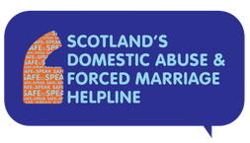
Click here for website Call 0800 027 1234

Strength for Tomorrow
Offers trauma-informed care and support to adults 16+ whose lives have been affected by childhood abuse.
Click here for website
6 Rubislaw Terrace, Aberdeen, AB10 1XE Mon–Fri, 9am–5pm strength@wearesft.org

Victim Support Aberdeen
Provide support and information to people affected by crime. Click here for website
Top Floor, 40 Union Terrace, Aberdeen, AB10 1NP Mon–Fri, 9am–5pm victimsupport.aberdeen@victimsupportsco.org.uk

The Spark
The Relationship Helpline is available for those needing to talk to about a relationship problem. Helpline Counsellors are available Monday to Friday. Service is completely free of charge in Scotland and confidential.
Click here for website Call 08088 022088

7

Help with Everyday Living



8



Instant Neighbour
Help with Everyday Living
Supports those on low incomes to set up home. Click here for website
Call 01224 489955
5 St Machar Drive, Aberdeen AB24 3YI. reception@instantneighbour.co.uk

Change Works
Offers free, practical advice, and information on energy related matters.
Online Referral Form

Energy Advice Scotland Call 0808 196 9660
Offer free practical advice and information on energy related matters
Click here for website
Aberdeen City Council
The Council has a free support line for those:
- facing crisis
- extreme hardship due to the rising cost of living
- struggling with mental health challenges
- experiencing domestic abuse or concerned about a family member/friend.
Community Support team can be contacted on 0800 0304 713

Food parcels can be collected from locations across the city. Click on the link below to find your nearest one.
Times and p laces to collect emergency food | Aberdeen City Council

Community emergency food provision venues Local Emergency food p rovision MAP LINK

Scottish Welfare Fund
Provides financial support for those facing a crisis or need help to live in the community. Two types available; crisis grants and community care grants, and they do not need to be paid back.
App ly to the Scottish Welfare Fund | Aberdeen City Council


9

SCARF
Scarf delivers free and impartial energy efficiency advice and services.
Click here for website Call 01224 213005
1 Cotton Street, Aberdeen AB11 5EE. info@scarf.org.uk

Aberdeen Cyrenians
Food, clothing, toiletries, household items, bedding. Referrals accepted.
Click here for website Call 0300 303 0903
Mon–Fri, 9am–5pm, Fri, 9am–4pm.


Drop-in at 62 Summer Street, Aberdeen AB10 1SD. directaccess@weareac.org

Home Energy Scotland Call 0808 808 2282
Offer free and impartial advice on energy saving, keeping warm at home, renewable energy.
Housing
Aberdeen City Council Housing online
Help with Everyday Living
Call 03000 200 292 (ask for Housing Advice Information)
Homelessness Call 0800 9176 379 (24 hour)

Local Councillor
For contacting your local community council click the link:
Community Councils | Aberdeen City Council

Scottish Fire & Rescue Service Free home safety checks.
Click here for website Call 01224 618342

Housing Officer
Aberdeen City Council - request housing supp ort

TogetherAll
Free UK where people can share their feelings and get help from others who understand. Join anonymously and access practical tools.
Click here for website



10

ABZWorks Employability Support Anyone living in Aberdeen seeking employability support.
Help with Everyday Living
Click here for website Helpline on 01224 346100
abzworks@aberdeencity.gov.uk

Social Security Scotland
Managing benefits including Five Family Payments, Disability benefits, Carers benefits, Heating benefits etc.
Social Security Scotland - Homepage Call Freephone 0800 182 2222 Mon–Fri, 8am–5pm
Aberdeen Foyer - Employability Offer support with:
- Job searching
- CV building
- Interview skills
- Work experience
- Sector-based training
- In-work support to increase opportunities for progression
- Reviewing and improving transferable skills
- Working to achieve confidence building
- Support with health and wellbeing
- Reviewing financial concerns and offering financial advice
- Access to interview clothes
- Digital skills
They can also provide PPE before starting work, cover bus fares to appointments, and provide digital kit where possible.
They work with clients on a 1:1 basis, and in group sessions, in a friendly and welcoming environment.
Click here for website info@aberdeenfoyer.com




11

Money, Benefits and Work




Money/Finances
12
Money, Benefits and Work

Aberdeen City Council Benefits and Money Advice Team
Provide free, impartial, and confidential advice
including helping to complete claim forms, checking entitlement to benefits.
Click here for website

Aberdeen City Council Financial Inclusion Team Click here for website
Mon–Fri, 8.30am–5pm.
Call 03000 200 292
moneyadvice@aberdeencity.gov.uk

ACC Benefits calculator Benefits Calculator link Benefits and Advice link
For urgent financial assistance, contact -
Aberdeen Financial Inclusion Team Call 01224 069769

Aberdeen Jobcentre
Public service & government in Aberdeen Click here for website
12 Dee St, Aberdeen AB11 6DR
Mon, Tues, Thurs, Sat 9am-5pm Wed 10am-5pm
Fri 9am-4pm 0800 169 0190

Scottish Welfare Fund Freephone
The Scottish Welfare Fund provides emergency and crisis grants for those in financial difficulty.
App ly to the Scottish Welfare Fund | Aberdeen City Council
Call 0800 03 04 713

Independent Food Aid Network
Provides information on cash first referrals. Cash First Leaflets | IFAN


13

Citizens Advice Scotland
Help to Claim service for Universal Credit. Free, independent, and confidential.
Click here for website Mon–Fri, 8am-6pm.
Chat online to an advisor at cas.org.uk/helptoclaim (Mon-Fri, 8am-6pm)
Call free 0800 023 2581
Citizens Advice Scotland - Money Outreach Projects Outreach projects in Northfield Community Centre, Powis Community Centre and Torry Medical Centre Click here for outreach p rojects
41 Union Street, Aberdeen AB11 5BN. Call 01224 569750
Money, Benefits and Work
bureau@aberdeencab.casonline.org.uk

Citizens Advice Scotland Money Advice Team Free and confidential advice on dealing with debt,
benefits, and other financial support, ways to save money.
Click here for website Call 0800 028 1456
moneytalkteam.org.uk

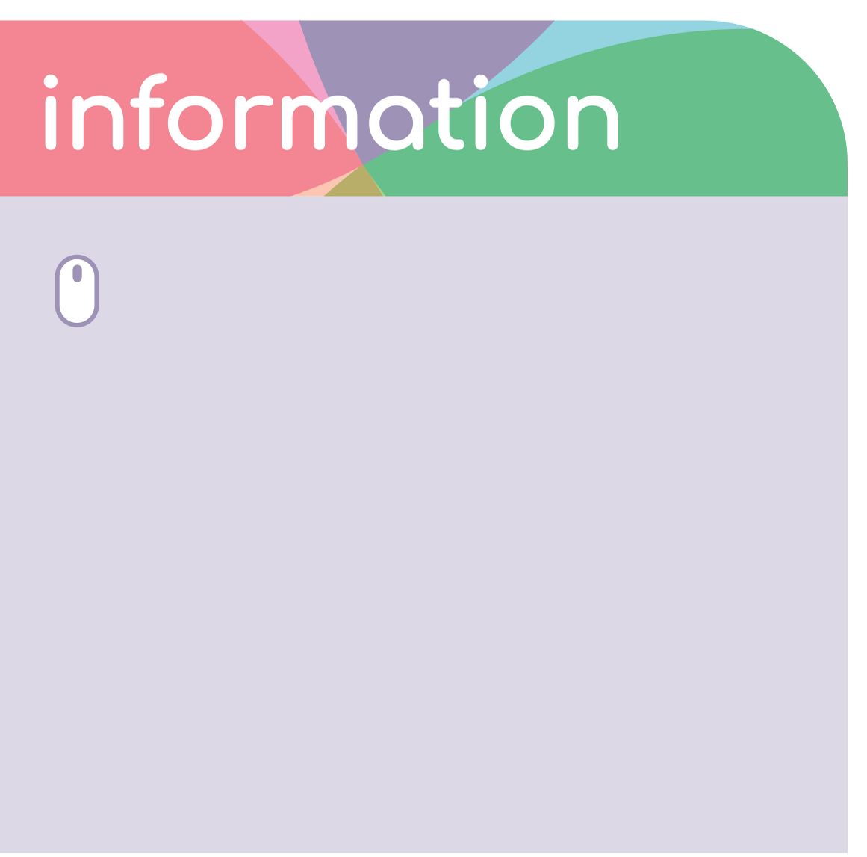


CFine Safe Team
For budgeting advice or a free benefit check. (SAFE = Support, Advice, Finance & Education). click here for website




14

Grampian Credit Union
Money, Benefits and Work
Grampian Credit Union provides access to savings, loans, online banking, and insurance. Click here for website
250 Union Street, AB10 1TN. Call 01224 561 506 admin@grampiancreditunion.co.uk
Cyber and Fraud Centre
Provide services to the public and organisations on reporting and legal Guidance, victim assistance, fund recovery, and educational resources.
Click here for website Call 01786 447 441
Incident Response Helpline: 0800 167 0623






Foyer Aberdeen
Foyer Aberdeen Money Managing Team Provide free, confidential and impartial money and budgeting advice to people aged 16 and over.
Managing your Money — Aberdeen Foyer


15

Aberdeen Cyrenians
Money, Benefits and Work

Open to anyone who is having difficulties with digital and financial exclusion.
Support to navigate essential services such as Universal Credit, energy, banking, job search, budgeting, training opportunities. Drop-in at Summer Street. Referrals accepted.
Click here for website Call 0300 303 0903
62 Summer Street, Aberdeen AB10 1SD Mon–Fri, 9am–5pm


Aberdeen City Council - Being Unemployed
For those experiencing unemploymet click on the below link Click here for website

Step Change

Support and advice for with Debits. Click here for website
Contact us on 0800 138 1111
Monday to Friday 8am to 8pm and Saturday 9am to 2pm

16

Support for staying well



General Support
17
Support for staying well

NHS Inform
Health information for anyone in Scotland. Click here for website
Call 111

NHS Grampian
Click here for website
Call 0345 456 6000 for Aberdeen Royal Infirmary.

Aberdeen City Health & Social Care Partnership
Click here for website
Includes AGILE (Aberdeen Guide to Independent Living and Enablement) ACHSCP AGILE Booklet

Aberdeen City Council
Click here for Wellbeing & Supp orted Services

Citizens Advice Scotland
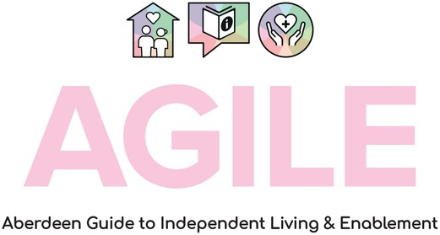
No drop-in service, by appointment only. Click here for website
Call 01224 569750
41 Union Street, Aberdeen AB11 5BN bureau@aberdeencab.casonline.org.uk
GP
Registering with a GP p ractice | NHS Inform

Health Visitors Contact G.P. Practice.

Speech and Language Therapists Contact G.P. Practice.

Occupational Therapy
For home checks and aids for independent living. Call 0800 141 2339
OTDuty@bonaccordcare.org Doctor/Dentist
Accessing the NHS.
Accessing and using the NHS in Scotland | NHS inform



NHS Grampian Primary Care Link Worker Click here for website


18

Polish Association Aberdeen
Support for staying well
Offer psychological help, actively promote healthy lifestyles among the Polish community. Self-referral scheme by email.
Services include Cognitive Behavioural Therapy (CBT), Person Centred Counselling, low-intensity guided psychological interventions, suicide prevention, and support for children and teenagers with autism spectrum disorder.
Click here for website info@paaberdeen.co.uk

G.P.
Registering with a GP p ractice | NHS inform
How to register with a G.P. Practice.
Dental
Informaiton on which dental practices are registering patients, advice on looking after your teeth, contact numbers.
Click here for website
Dental Information and Advice Line (DIAL)
Available for patients to talk to qualified dental nurses, who will and give an emergency appointment if necessary, give advice for dental problems, and provide details of local NHS dentists.
Click here for website Call 0345 45 65 990
Mon–Fri, 8.05am-6pm

Out-of-Hours Emergency Dental Service (GDENS) Click here for website
For pain or genuine dental emergency on a weekend or out of hours. NHS 24 will assess and issue an emergency appointment if necessary. If an appointment is given, NHS charges and exemptions will apply to any treatment.
Call NHS 24 on 111





19

Fit like? Family Wellbeing Hubs
‘Fit Like? Family Wellbeing Hubs | Aberdeen City Council Fit like? Family Wellbeing Hubs are a group of services working together to support children and young people’s mental wellbeing.
Support with:
- Finance and benefits
- Family relationships and communication
- Coping with daily pressures
- Promoting positive emotional and mental wellbeing
- Talking about traumatic things that have happened Who is the Hub Team?
- Children 1st
- Health - Health Visitors, Family & School Nurses, Child & Adolescent Mental Health Service (CAMHS)
- Community Learning and Development – Family Learning, Adult Learning, Youth Work, Communities Team, Educational Social Workers
- Library and Information Services
- Creative Learning
- Social Work
- Education
- Alcohol & Drugs Partnership (ADP)

To access help contact by e-mail Fitlikehubs@aberdeencity.gov.uk or to a Teacher, Health Visitor or Family Nurse.
Self-Directed Support Aberdeen
Helps people to have choice, control and flexibility over their care and support.
Support for staying well
Click here for website Call 01224 523837
SDSHelpline@aberdeencity.gov.uk

ALISS – A Local Information System for Scotland. Find services, groups and activities for health and wellbeing across Scotland.
Click here for website

Telecare
To help you live independently at home. Click here for website
Call 01224 788616
Communityalarm@bonaccordcare.org

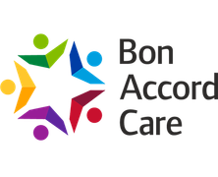



Mental Health
20
Support for staying well
Samaritans
24-hour confidential emotional support service. Click here for website
Call 116 123

Breathing Space
Free and confidential phone-line service. Click here for website
Call 0800 83 85 87
Mon–Thurs, 6pm-2am
Fri, 6pm-Mon 6am (open 24 hours at weekends).

Aberdeen Self Harm Service
Support for those living with self-harm. Aged 16 and over.
Click here for website Selfharm.Aberdeen@penumbra.org.uk



Urgent help Call 999

Emergency services for a medical emergency or someone’s life is in danger

Childline
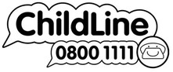
Free confidential service for children and young people. Click here for website
Call 0800 1111 (24-hour helpline)

CAMHS – Child and Adolescent Mental Health Service Outpatient based mental Health service, supports individuals 0-18 years. Referral only service.
Click here for website Mon–Fri, 9am–5pm.

Penumbra365
Free self-referral service for people aged 18 years and above who require immediate, short-term support and those who may be in distress.
Click here for website Call 01224 074 550
168 Skene Street AB10 1PE - For drop ins penumbra365@penumbra.org.uk
Mon–Fri, 9am–5pm

Social Care and Well-being Out of Hours (Aberdeen) Range of social work services
Call 0800 7315 520
Mon–Fri, 4.30pm–Midnight
Weekends/public holidays 8.30am to midnight. OOHS@aberdeencity.gov.uk

21

Connecting with You
Connecting With You is a free service run by the British Red Cross. It’s available to all people aged 18 or over in Scotland who are experiencing issues associated with loneliness. Connecting With You aims to help you rebuild your independence.
Connecting with you website link Mon–Fri, 10am-4pm


Call 0300 30 36 077 (Calls are free). connecting-withyou@redcross.org.uk

NHS Inform - Mental Health Provides information around identifying,
treating, and managing mental health problems, and disorders.
Men In Mind
Men's peer to peer support group. Men in Mind Facebook Link meninmindaberdeen@gmail.com
Support for staying well

Andy’s Man Club
Free peer to peer support group that provides a place for men to come together in a safe and open environment to talk about the issues or problems that they have faced or are currently facing. Various locations and online meetings available.
Click here for website info@andysmanclub.co.uk

The Bounds
Freely available counselling service for person-centred counselling programme at the University of Aberdeen for the local community. Also available for children and young people. Self-referral by email or telephone, or through G.P/other health professional.
Click here for website
19 College Bounds, Old Aberdeen, AB24 3DX thebounds@abdn.ac.uk






Foyer Aberdeen - FitMind Team
Provides counselling, suicide prevention etc. Accept self-referral and referrals from professionals.
Click here for website
Counselling@aberdeenfoyer.com
Mind
Mind have produced a helpful guide to offer support to people around taking care of your mental health and wellbeing during this time.
Click here for website
Living Life
Free appointment-based telephone service for anyone over the age of 16 with low mood, depression and anxiety.
Click here for website Call 0800 328 9655
Mon – Fri, 1pm – 9pm
Every Mind Matters
22
Support for staying well
NHS UK site which provides some tips on how to support your Mental Health and Wellbeing, alongside other conditions such as anxiety, sleep, stress, and low mood.
Click here for website

Shout Crisis Text Line
UK Text Line that provides free confidential support, 24/7 via text It’s the first free 24/7 texting service in the UK for anyone in crisis anytime, anywhere.
Click here for website Text Shout to 85258

Re-Think Mental Illness
For practical advice on different types of therapy and medication, benefits, debt, money issues, police, courts, prison, and your right under the Mental Health Act.
Click here for website
Call 0300 5000 927 (Calls are charged at your local rate) Mon–Fri, 10am-2pm

SAMH – Scottish Association for Mental Health Mental health support
Click here for website 0344 800 0550
info@samh.org.uk
Hear for You: Free 1:1 wellbeing and practical support for Aberdeen City Council tenants, or anyone affected by RAAC directly or indirectly. Up to 8 sessions each of wellbeing coaching and link support. Self refer via this link: Hear for You or email hearforyou@samh.org.uk

Men’s Support
23
Support for staying well


Men In Mind
Men's peer to peer support group. Men in Mind Facebook Link meninmindaberdeen@gmail.com


Men’s Shed
Community spaces where men can enjoy practical hobbies, make friends, learn, and share skills.
Find a local Men’s Shed

Andy’s Man Club Click here for website
Free peer to peer support group that provides a place for men to come together in a safe and open environment to talk about the issues or problems that they have faced or are currently facing. Various locations and online meetings available. info@andysmanclub.co.uk

The Kickabout Aberdeen (TKA)
TKA is a Men's Mental Health and Wellbeing Charity, supporting dads, grandads, step-dads and guardians regardless of age or ability. TKA help aid with mental health and general wellbeing through football in a fun relaxed environment.
LINK to website LINK to Facebook

Quitting Smoking
Support for staying well
Pharmacy
Pharmacies | NHS Inform

G.P.
Contact G.P. practice Find a GP Practice

Quit Your Way Service
Support is free, local and confidential. Receive advice and access to free stop smoking medications such as Nicotine Replacement Therapy (NRT).
The service is also those dual using tobacco and electronic cigarettes/vaping devices.

Quit Your Way Scotland call 0800 84 84 84. Open 7 days a week: Mon-Fri, 8am–10pm and Sat & Sun, 9am–5pm or chat online at this website link
HealthPoint and NHS Grampian’s stop smoking service can be contacted using any of the following;
NHS Grampian Healthline call 08085 20 20
30
Email: gram.healthpoint@nhs.scot

Healthy Eating
NHS Grampian Healthy Eating
24
For up to date healthy eating advice and links to resources,
NHS Grampian Healthy Eating

NHS Inform Healthy Living
For up to date information on food and nutrition NHS Inform Food & Nutrition

ALISS - A Local Information System for Scotland
Find health and wellbeing services, groups, and activities across Aberdeen and Scotland.
ALISS resource

HealthPoint
Call 0808 520 2030

Text “info” to 82727 Click here for website



Drug and Alcohol Support
25
Support for staying well

Alcohol & Drugs Action
Provide support every step of the way for drug and alcohol addiction.
Link to Drop -in services available across the city

Aberdeen City Council - Aberdeen Protects Call 01224 594700
Call 0333 3 448 355 (from landlines & pay monthly contracts
only) or 07927 192 706 (Mon-Fri, 10.30am–1pm, 2pm–5pm. Sat & Sun, 2pm–5pm).
Alternatively call 01224 594700

Drop in service at 7 Hadden Street, Aberdeen. AB11 6NU. info@alcoholanddrugsaction.org.uk
NHS Grampian HealthPoint
For local help, advice, and support. Where to find your local Healthpoint Call 08085 202030

Crew
Crew support people to reduce harm, challenge perceptions, and help people make positive choices about their use of drugs.
Click here for website Call 0131 220 3404
Mon-Fri, 10am–5pm

Aberdeen in Recovery (AiR)
AiR support those in recovery from addiction, and their family and friends.
Aberdeen in Recovery
1st Floor Left, 41 Union Street Aberdeen
AB11 5BN
Call 01224638342
info@aberdeeninrecovery.org



26

Further Support & Community life



Cancer Support
27

Macmillan
For anyone undergoing cancer treatment only. Free, independent, and confidential advice.
Click here for website

CAB Macmillan Cancer Outreach Call 01224 557116
Click here for website
Roxburgh House, Ashgrove Road, AB25 3BX Mon–Fri, 9.30am–4pm Grampian.macmillan@aberdeencab.casonline.org. uk



Marie Curie
For patients and their families to support and advice for end of life Click here for website
Call 0800 090 2309
Mon - Sun
CLAN Cancer Support Services available:
- Emotional support and counselling
- Complementary Therapies
- Nutrition, Health, and Wellbeing Support
- Children and Family Service
- Clan Haven Accommodation (Bed and Breakfast)
- Cancer Support Groups Click here for website
Clan House, 120 Westburn Road, Aberdeen, AB25 2QA.
Call 01224 647000
enquiries@clancancersupport.org

Maggie’s Aberdeen
Support for those diagnosed with Cancer and their families. No appointment needed, just pop in.
Click here for website
Maggie's Aberdeen. Elizabeth Montgomerie Building, Aberdeen Royal Infirmary, AB25 2UZ Mon–Fri, 9am–5pm.
Call 01224 645928
aberdeen@maggies.org


Further Support & Community life

Carers
28

Quarriers
Aberdeen Carers Supp ort Service - Virtual Carers Centre Call 0224 914 036

Aberdeen Carers Support Service. 50 Gilcomstoun Park, AB25 1NX aberdeencarers@quarriers.org.uk


Barnardos – Young Carers Service Click here for website
Call 01224 624090
20 Carden Place, AB10 1UQ AberdeenYoungCarers@barnardos.org.uk

VSA

Carers support, care, day-care and support. Click here for website
Call 01224 212021.
info@vsa.org.uk

Bon Accord Care
Information on a range of services including personal care/support in the home, day services, respite for carers, occupational therapy, telecare, and wellbeing activities.
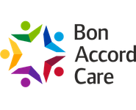
Click here for website Call 01224 570400
bacinfo@bonaccordcare.org

A carer is anyone who is unpaid for their caring and looks after a friend, family member, or neighbour due to old age, physical, or mental illness, disability, or an addiction. There is no minimum amount of time you need to support someone for you to be considered a carer. It could be as little as 1 to 2 hours every few weeks.
What are your rights as a carer? | Carers Scotland

Becoming a Carer - Aberdeen City Council Call care management: 01224 264004 Arrange care or support at home.

Occupational Therapy
For home checks and aids for independent living.
Call 0800 141 2339
OTDuty @ bonaccordcare.org

Further Support & Community life

Youth Support
29

Aberdeen Youth Movement
Further Support & Community life

Age group 14–25 years. Opportunities include Youth Action Committee, Mentoring Scheme, Scottish Youth Parliament, and ongoing youth related events.
Click here for website bwebb@aberdeencity.gov.uk Call 01224 523103

Aberdeen City Council Young Person’s Rights Service
Call/Text 07876 780877 or 07484 004966
Aberdeen City Council - Young People's Rights YoungPersonsRights@aberdeencity.gov.uk
Nightstop
Safe place for young people to stay Call 01224 562863
Nightstop — Aberdeen Foyer nightstop@aberdeenfoyer.com

ACIS Youth CIC

Counselling for children/young people and families
Click here for website
LGBT Youth Scotland Zone Youth Aberdeen
Charity for LGBTQ+ young people aged 13–26 years Click here for website andiwatson@aberdeencity.gov.uk
Meet 2nd Saturday each month 12–3pm

Barnardo’s
Employability training and support to 16–24 years. Click here for website
Call 01224 624090
20 Carden Place, AB10 1UQ. Mon–Fri, 9am-5pm miranda.aitken@barnardos.org.uk

Foyer Aberdeen - Employability Team
Training courses for young people seeking employment. Employability — Aberdeen Foyer info@aberdeenfoyer.com
Foyer Aberdeen - Futures Team Support for young people aged 12-24. Foyer Futures — Aberdeen Foyer
Call 07487 239958
Ashley.mccorquodale@aberdeenfoyer.com Foyer Aberdeen - Housing Team
Homelessness helpline call 0800 9176379 (24-hours). Housing — Aberdeen Foyer
Referral through Aberdeen City Council Housing Advice Service.

Family Support
30
Aberdeen City Council - Becoming a Parent
If you are worried about the safety of a child in Aberdeen.

Aberdeen City Council - Child Protection
Call 0800 731 5520 (Joint Child Protection Team)
Call 0800 731 5520 (Emergency Out of Hours) Call 101 (Police Scotland)
Contact even if you are unsure, then steps can be taken to assess the risk to the child and, if needed, to protect them.

Childline Scotland Click here for website Call 0800 11 11
Information, advice, and support

Befriend A Child

Charity which supports school-aged children growing up in difficult life circumstances.
Click here for website
9 Bon-Accord Square, AB11 6DJ Call 01224 210060

Befriend a Child Community Youth Clubs
Cummings Park, Northfield, Kincorth Community Centres.

Health Visitor Contact GP practice.

Aberdeen City Council - Family Learning
Early intervention, holistic support service for families. One-to-one or small groups, courses include sleep, first aid, literacy/numeracy for parents digital awareness for parents, understanding emotions.
Click here for website Call 01224 070407

Nurseries
Use link to search for childcare and nurseries. Childcare (Family Information Services) | Aberdeen City Council

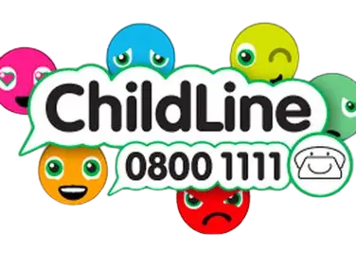
Further Support & Community life

31

Home Start
Further Support & Community life
Practical and emotional support to families with young children.
Click here for website
Main office: Langstane House, 6 Dee Street, Aberdeen AB11 6DR
Call 01224 693545
admin@homestartaberdeen.org.uk

Somebody Cares Scotland Client showroom and foodbank
Provide free food, furniture, and clothing. Click here for website
Call 01224 460700 (option 1)
info@somebodycaresscotland.org

Family Learning
Courses include sleep, first aid, literacy/numeracy digital awareness for parents and understanding emotions.
Call 01224 070407
familylearning@aberdeencity.gov.uk

Best Start
Best Start Grant and Best Start Foods are payments that help towards the costs of being pregnant or looking after a child.
Best Start Grant and Best Start Foods - mygov.scot
PEEP
Sessions include songs, stories, play activities. Groups are free and available to any parents and carers with children from birth to 5 years. Delivered by Peep and a range of nursery/early years staff across Aberdeen.
Peep | Aberdeen City Council Call 01224 248389
peep@aberdeencity.gov.uk

AberNecessities
Provides disadvantaged families with the essential and basic necessities that no child should go without for children aged 0-18 years.
Click here for website Call 01224 784000

My Rights, My Say


The service supports children in Scotland aged 12–15 with additional support needs to understand and exercise their rights to be involved in decisions about their learning. Click here for website

Bereavement/Grief Support
32
Further Support & Community life
Aberdeen City Council - Death of a loved one

Hope Again
Click here for website
Youth website of Cruse Bereavement Support.

Survivors of Bereavement by Suicide
Offer a very discreet peer support network, locally facilitated by SHMU
Click here for website sarah.igesund@shmu.org.uk
The group meets the 3rd Wednesday of every month, 6.30-8.30pm.
Call 07538 720053
aberdeen@uksobs.org

NHS Inform

Death and bereavement | NHS nform Coping with grief | NHS inform




Cruse Bereavement Care Scotland Aberdeen
Exists to help people understand, process, and navigate their grief.
Click here for website
42A Rose Street, Aberdeen.
Free support helpline call 0808 802 6161 support@crusescotland.org.uk

CAMHS (Child and Adolescent Mental Health Service) Bereavement in Aberdeen City
Call 01224 550139
CAMHS, Links Unit, City Hospital, Park Road. AB24 5AU. Mon–Fri, 9am–5pm

Archie Child Bereavement Service
Provides support for families affected by bereavement. Click here for website

Sunrise Partnership
Provide free, therapeutic, and confidential support for children and young people up to age 18 who have experienced loss or bereavement.
Click here for website

Winston’s Wish
Supports children and young people after the death of a parent or sibling.
Click here for website

Gambling Support
English is not my first language


RCA Trust
33
Further Support & Community life
A charity that provides prevention and treatment services for gambling-related harms and alcohol and drug use in Scotland.
Click here for website Call 0141 887 0880
info@rcatrust.org.uk
AlLA
Offers support resources and community for women experiencing or affected by gambling harms.
Click here for website
Contact email: hello@aila-scotland.co.uk

Citizens Advice Scotland Gambling Support Service gamblingsupport@scottishcabs.org.uk For those affected by gambling.


Aberdeen City Council Communication support Translation, interpreting, and communication support services, British Sign Language.
Aberdeen City Council - Communication Supp ort

GREC
Services: support & advice, translation & interpreting, counselling, language café, and English classes.

Click here for website Call 01224 595505
680 King Street, Aberdeen AB24 1SL. info@grec.co.uk

Digital/Phone Access - Aberdeen Cyrenians

Access to phones, digital support and internet, drop-in at 62 Summer Street, Aberdeen AB10 1SD. Referrals accepted.
Call 0300 303 0903
Mon–Fri, 9am–5pm, Fri, 9am-4pm Polish Association
Click here for website
Call 0756 3221790
info@paaberdeen.co.uk Wed & Fri, 6pm–7.30pm Sat, 10am-11.30am
2nd Floor, 35A Union Street, Aberdeen. AB11 5BN.

Community Transport
34

Services operate in Aberdeen City. Mon-Fri, 10am- 2.30pm.
To book, call 01224 523765.
The booking line is open Mon-Fri, 9am–4pm.

Bookings will be taken 7 days in advance and must be booked at least 24 hours before travel.
New users are required to complete a membership form when they first travel on the buses.
Aberdeen City Council - Community Transport link

Libraries
Aberdeen City Council - Find a library Opening times vary



THInC (Transport to Healthcare Information Centre)
The service provides a dedicated telephone service offering guidance on accessing suitable transport options to get to and from appointments when a person has no means of personal transport.

The centre can provide details of suitable bus or train times, contact telephone numbers and other services such as local dial-a-bus, or voluntary car schemes.

THInC does not book transport but can assist with travel advice. Click here for website
Call 01467 536111. Calls are charged at local rate.
Mon–Fri, 9am–4pm travel@thinc-hub.org

Further Support & Community life



Get Active
35


Sport Aberdeen
Further Support & Community life
Sport Aberdeen manages 30 venues across the city. Venues include swimming pools, sports centres, outdoor pitches, and golf courses. Click venues link to access timetables.
Venues - Sport Aberdeen

Aberdeen city residents in receipt of recognised benefits and allowances and those of pension age of 66 and over, Sport Aberdeen offer discounts. Click link below.
Click here for website


Sport Aberdeen Health Walks
Walk Aberdeen's health walks are part of Sport Aberdeen's Active Lifestyles programme aimed at helping people stay active, whatever their age.
Designed as a low intensity walk for those who want to get a bit more active or are living with, or recovering from, a long-term health condition.

Walk Aberdeen runs a range of low-level, friendly walks from buggy, Macmillan Friendly, dementia, and disability Inclusion walks.
Click here for website
Brian Harrison. Call 01224 047928 BHarrison@sportaberdeen.co.uk

The Stand Up To Falls - Sport Aberdeen Team offer falls awareness in the community
through their pop up stand with information, top tips, and signposting.
Click here for website
For more information contact the team directly on 01224 507701 or email ActiveLifestyles@sportaberdeen.co.uk

Further Services
36

Aberdeen Care and Repair
Aberdeen Care and Repair can offer services to residents of Aberdeen City.
Click here for website Call 01224 251133
Community Centres/Learning Centres
Contact individual community or learning centre for an up-to-date timetable of activities.
Click here for community centres Click here for website learning centres

Out of Hours Social Work For emergencies/crises. Call 0800 7315 520
OOHS@aberdeencity.gov.uk

Aberdeen Cyrenians
Provides support for anyone struggling in the North East.
Click here for website
62 Summer Street, AB10 1SD Call 0300 303 0903
Alzheimer Scotland Aberdeen- Brain Health & Dementia Resource Centre
The centre aims to support people with dementia, their family, relatives, and friends at any stage of the illness. Click here for website
Call 01224 644077
24-hour freephone Dementia Helpline 0808 808 3000. 13-19 King Street, AB24 5AA.
Mon–Fri, 9am–5pm.

DPHS Aberdeen
DPHS Aberdeen is a local charity offering housing options advice, information and advocacy to disabled people, their families and carers.
To find out how we can help you simply click here to find out more about our services.

Further Support & Community life


Further Support & Community life

37

North East Sensory Services

Achieving independence for blind and deaf people. An independent local charity and the first integrated joint sensory service in Scotland, delivers information, equipment, and support.
Click here for website Call 0345 271 2345
Text 07593 102 004

4 Pillars

LGBT+ Charity that supports the community through mental, emotional, physical and sexual health.
Click here for website 01224 211963
33 Regent Quay, AB11 5BE mail@fourpillaruk.org

The Period Place

Charity that provides education, awareness, and support for people of all ages and genders on periods and menstrual health.
Click here for website
Unit 4, Glover Pavilion, Campus 3, Balgownie Drive. Bridge of Don. AB22 8GW info@theperiodplace.co.uk


38

Also available - AGILE Aberdeen Guide for Independent Living & Enablement
ACHSCP Our Delivery|AGILE swsc@aberdeencity.gov.uk
For anyone who wants to know about the help and support that is available in Aberdeen to enable them to stay as independent as possible in their own home.
ACHSCP AGILE Booklet
If you want this document translated into another language or format (including Braille, large print, audio disc or BSL DVD) please contact us via email: healthimprovement@aberdeencity.gov.uk


